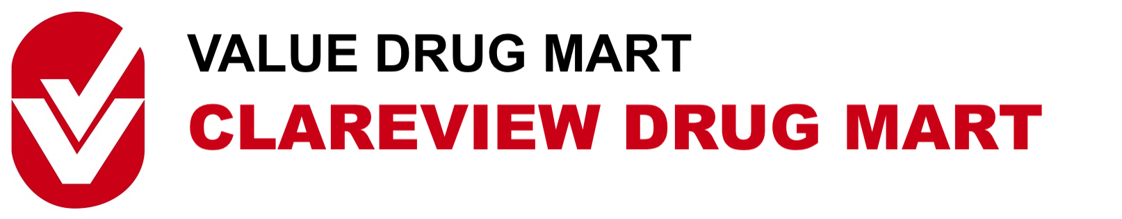

Clareview Drug Mart has served our neighborhood since October 1981. We are a customer focused business whose staff is dedicated to meeting the needs of our clientele.
We are looking for someone to join our pharmacy team located at Clareview Drug Mart. Duties would include but are not limited to:
- Dispensing prescription medications
- Putting away pharmacy stock
- Aid in cashier responsibilities
- Compounding medications
- Working with our pharmacists to provide optimal care for our patients
Knowledge in Kroll software is an asset

Clareview Drug Mart
14061 Victoria Trail NW
Edmonton, AB, T5Y-2B6
P: 780-473-0832
F: 780-478-4125

